为了保证数据的一致性，给必要的增删改设置触发器，某些触发器没有测试是因为它牵扯到其他数据，之后建立完善时候会全部测试。（标橙的触发器已经建立完善）

**删除学院：**

CREATE TRIGGER trg_delete_College

ON [education].[dbo].[学院]

INSTEAD OF DELETE

AS

BEGIN

-- 开启事务，保证数据一致性

BEGIN TRANSACTION;

BEGIN TRY

-- 删除属于表中的相关记录

DELETE FROM [education].[dbo].[属于]

WHERE [学院ID] IN (SELECT [学院ID] FROM deleted);

-- 删除编制表中的相关记录

DELETE FROM [education].[dbo].[编制]

WHERE [学院ID] IN (SELECT [学院ID] FROM deleted);

-- 删除导师表中的相关记录

DELETE FROM [education].[dbo].[导师]

WHERE [学院ID] IN (SELECT [学院ID] FROM deleted);

-- 删除招生目录条目表中的相关记录

DELETE FROM [education].[dbo].[招生目录条目]

WHERE [学院ID] IN (SELECT [学院ID] FROM deleted);

-- 删除学院表中的记录

DELETE FROM [education].[dbo].[学院]

WHERE [学院ID] IN (SELECT [学院ID] FROM deleted);

-- 提交事务

COMMIT TRANSACTION;

END TRY

BEGIN CATCH

-- 回滚事务，避免删除失败导致的数据不一致

ROLLBACK TRANSACTION;

-- 抛出错误信息

THROW;

END CATCH;

END;

**删除招生目录时：**

CREATE TRIGGER trg_InsteadOf_Delete_招生目录

ON [education].[dbo].[招生目录]

INSTEAD OF DELETE

AS

BEGIN

-- Step 1: 删除包含3表中的相关记录

DELETE FROM [education].[dbo].[包含3]

WHERE [招生目录ID] IN (SELECT [招生目录ID] FROM DELETED);

;

-- Step 3: 删除招生目录表中的记录

DELETE FROM [education].[dbo].[招生目录]

WHERE [招生目录ID] IN (SELECT [招生目录ID] FROM DELETED);

END;

**删除招生目录条目时：**

CREATE TRIGGER trg_InsteadOf_Delete_招生目录条目

ON [education].[dbo].[招生目录条目]

INSTEAD OF DELETE

AS

BEGIN

-- Step 1: 删除 编制 表中的相关记录

DELETE FROM [education].[dbo].[编制]

WHERE [招生目录条目ID] IN (SELECT [招生目录条目ID] FROM DELETED);

-- Step 2: 删除 包含2 表中的相关记录

DELETE FROM [education].[dbo].[包含2]

WHERE [招生目录条目ID] IN (SELECT [招生目录条目ID] FROM DELETED);

-- Step 3: 删除 具有 表中的相关记录

DELETE FROM [education].[dbo].[具有]

WHERE [招生目录条目ID] IN (SELECT [招生目录条目ID] FROM DELETED);

-- Step 4: 删除 包含3 表中的相关记录

DELETE FROM [education].[dbo].[包含3]

WHERE [招生目录条目ID] IN (SELECT [招生目录条目ID] FROM DELETED);

-- Step 5: 删除 招生目录条目 表中的相关记录

DELETE FROM [education].[dbo].[招生目录条目]

WHERE [招生目录条目ID] IN (SELECT [招生目录条目ID] FROM DELETED);

END;

测试：

-- 删除 招生目录 表中的记录

DELETE FROM [education].[dbo].[招生目录]

WHERE [招生目录ID] = 2; -- 删除 招生目录ID 为 1 的记录

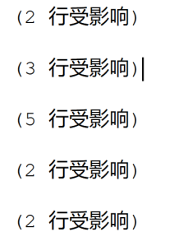

编制表中已删除

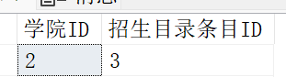

包含2已删除

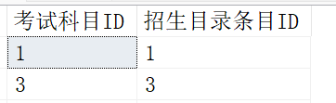

至此，测试 招生条目删除的时候可以正常删除，删除招生目录条目触发器已完善

测试招生目录：

-- 删除 招生目录ID = 1 的目录记录

DELETE FROM [education].[dbo].[招生目录]

WHERE [招生目录ID] = 1;

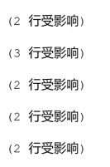

此时包含2被删除的信息是招生目录条目id对应的招生目录id为1的数据。

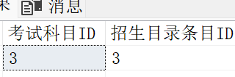

招生目录删除触发器已完善

因为一个招生目录包含n个招生条目，删除招生目录时候，需触发n个招生条目删除触发器，所以建立好招生目录条目触发器，招生目录触发器才得以完善。

**删除学科表时：**

CREATE TRIGGER trg_InsteadOf_Delete_学科

ON [education].[dbo].[学科]

INSTEAD OF DELETE

AS

BEGIN

-- 1. 删除 包含1 表中与被删除学科相关的记录

DELETE FROM [education].[dbo].[包含1]

WHERE [学科ID] IN (SELECT [学科ID] FROM DELETED);

-- 2. 删除 具有 表中与被删除学科相关的记录

DELETE FROM [education].[dbo].[具有]

WHERE [学科ID] IN (SELECT [学科ID] FROM DELETED);

-- 3. 删除 从属 表中与被删除学科相关的记录

DELETE FROM [education].[dbo].[从属]

WHERE [学科ID] IN (SELECT [学科ID] FROM DELETED);

-- 4. 删除 复试志愿 表中与被删除学科相关的记录

DELETE FROM [education].[dbo].[复试志愿]

WHERE [学科ID] IN (SELECT [学科ID] FROM DELETED);

-- 5. 删除 招生目录条目 表中与被删除学科相关的记录

DELETE FROM [education].[dbo].[招生目录条目]

WHERE [学科ID] IN (SELECT [学科ID] FROM DELETED);

-- 6. 最后删除 学科 表中的记录

DELETE FROM [education].[dbo].[学科]

WHERE [学科ID] IN (SELECT [学科ID] FROM DELETED);

END;

**删除考试目表时：**

CREATE TRIGGER trg_InsteadOf_Delete_考试科目

ON [education].[dbo].[考试科目]

INSTEAD OF DELETE

AS

BEGIN

-- 1. 删除 成绩 表中与被删除考试科目相关的记录

DELETE FROM [education].[dbo].[成绩]

WHERE [考试科目ID] IN (SELECT [考试科目ID] FROM DELETED);

-- 2. 删除 包含2 表中与被删除考试科目相关的记录

DELETE FROM [education].[dbo].[包含2]

WHERE [考试科目ID] IN (SELECT [考试科目ID] FROM DELETED);

-- 3. 最后删除 考试科目 表中的记录

DELETE FROM [education].[dbo].[考试科目]

WHERE [考试科目ID] IN (SELECT [考试科目ID] FROM DELETED);

END;

测试：

-- 删除 考试科目ID = 1 的考试科目记录

DELETE FROM [education].[dbo].[考试科目]

WHERE [考试科目ID] = 1;

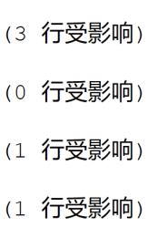

成绩、包含2均无考试科目ID为1的

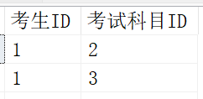

考试科目表删除触发器已完善

**删除导师触发器：**

CREATE TRIGGER trg_InsteadOf_Delete_导师

ON [education].[dbo].[导师]

INSTEAD OF DELETE

AS

BEGIN

-- 1. 删除 填报 表中与被删除导师相关的记录

DELETE FROM [education].[dbo].[填报]

WHERE [志愿ID] IN (SELECT [志愿ID] FROM [education].[dbo].[复试志愿]

WHERE [导师ID] IN (SELECT [导师ID] FROM DELETED));

-- 2. 删除 确定 表中与被删除导师相关的记录

DELETE FROM [education].[dbo].[确定]

WHERE [导师ID] IN (SELECT [导师ID] FROM DELETED);

-- 3. 删除 对应1 表中与被删除导师相关的记录

DELETE FROM [education].[dbo].[对应1]

WHERE [导师ID] IN (SELECT [导师ID] FROM DELETED);

-- 4. 删除 从属 表中与被删除导师相关的记录

DELETE FROM [education].[dbo].[从属]

WHERE [导师ID] IN (SELECT [导师ID] FROM DELETED);

-- 5. 删除 属于 表中与被删除导师相关的记录

DELETE FROM [education].[dbo].[属于]

WHERE [导师ID] IN (SELECT [导师ID] FROM DELETED);

-- 9. 删除 获得 表中与被删除导师相关的记录

DELETE FROM [education].[dbo].[获得]

WHERE [复试结果ID] IN (SELECT [复试结果ID] FROM [education].[dbo].[复试结果]

WHERE [最终导师ID] IN (SELECT [导师ID] FROM DELETED));

-- 6. 删除 选择 表中与被删除导师相关的记录

DELETE FROM [education].[dbo].[选择]

WHERE [导师ID] IN (SELECT [导师ID] FROM DELETED);

-- 7. 删除 复试结果 表中与被删除导师相关的记录

DELETE FROM [education].[dbo].[复试结果]

WHERE [最终导师ID] IN (SELECT [导师ID] FROM DELETED);

-- 8. 删除 复试志愿 表中与被删除导师相关的记录

DELETE FROM [education].[dbo].[复试志愿]

WHERE [导师ID] IN (SELECT [导师ID] FROM DELETED);

-- 10. 最后删除 导师 表中的记录

DELETE FROM [education].[dbo].[导师]

WHERE [导师ID] IN (SELECT [导师ID] FROM DELETED);

END;

**修改成绩触发器：**

成绩修改时，该考生的总成绩也会随之修改

CREATE TRIGGER trg_AfterUpdate_成绩

ON [education].[dbo].[成绩]

AFTER UPDATE

AS

BEGIN

-- 更新 初试 总成绩

UPDATE [education].[dbo].[总成绩]

SET [总分数值] = ISNULL(初试总分, 0)

FROM [education].[dbo].[总成绩] AS t

INNER JOIN [education].[dbo].[拥有] AS h

ON t.[总成绩ID] = h.[总成绩ID]

INNER JOIN (

-- 计算初试总分

SELECT c.[考生ID], SUM(c.[数值]) AS 初试总分

FROM [education].[dbo].[成绩] AS c

INNER JOIN [education].[dbo].[考试科目] AS k

ON c.[考试科目ID] = k.[考试科目ID]

WHERE k.[类别] = '初试'

GROUP BY c.[考生ID]

) AS 初试分数

ON h.[考生ID] = 初试分数.[考生ID]

WHERE t.[类别] = '初试';

-- 更新 复试 总成绩

UPDATE [education].[dbo].[总成绩]

SET [总分数值] = ISNULL(复试总分, 0)

FROM [education].[dbo].[总成绩] AS t

INNER JOIN [education].[dbo].[拥有] AS h

ON t.[总成绩ID] = h.[总成绩ID]

INNER JOIN (

-- 计算复试总分

SELECT c.[考生ID], SUM(c.[数值]) AS 复试总分

FROM [education].[dbo].[成绩] AS c

INNER JOIN [education].[dbo].[考试科目] AS k

ON c.[考试科目ID] = k.[考试科目ID]

WHERE k.[类别] = '复试'

GROUP BY c.[考生ID]

) AS 复试分数

ON h.[考生ID] = 复试分数.[考生ID]

WHERE t.[类别] = '复试';

END;

测试：

-- 假设更新 考生ID 为 1 的某门考试科目分数

UPDATE [education].[dbo].[成绩]

SET [数值] = 63

WHERE [考生ID] = 1 AND [考试科目ID] = 3;

如下图，修改初试成绩时，总成绩也被修改成为了正确数值：

成绩修改触发器已完善

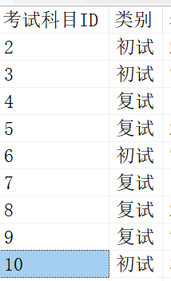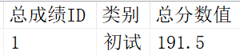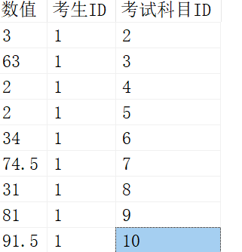

**删除考生表触发器：**

CREATE TRIGGER trg_InsteadOf_Delete_考生

ON [education].[dbo].[考生]

INSTEAD OF DELETE

AS

BEGIN

DELETE FROM [education].[dbo].[包含1]

WHERE [志愿ID] IN (SELECT [志愿ID] FROM [education].[dbo].[复试志愿]

WHERE [考生ID] IN (SELECT [考生ID] FROM DELETED));

DELETE FROM [education].[dbo].[选择]

WHERE [志愿ID] IN (SELECT [志愿ID] FROM [education].[dbo].[复试志愿]

WHERE [考生ID] IN (SELECT [考生ID] FROM DELETED));

-- 3. 删除 确认 表中与被删除考生相关的记录（考生-复试结果关系）

DELETE FROM [education].[dbo].[确定]

WHERE [复试结果ID] IN (SELECT [复试结果ID] FROM [education].[dbo].[复试结果]

WHERE [考生ID] IN (SELECT [考生ID] FROM DELETED))

-- 6. 删除 填报 表中与被删除考生相关的记录

DELETE FROM [education].[dbo].[填报]

WHERE [考生ID] IN (SELECT [考生ID] FROM DELETED);

-- 9. 删除 对应2 表中与被删除考生相关的记录

DELETE FROM [education].[dbo].[对应2]

WHERE [考生ID] IN (SELECT [考生ID] FROM DELETED);

-- 5. 删除 拥有 表中与被删除考生相关的记录

DELETE FROM [education].[dbo].[拥有]

WHERE [考生ID] IN (SELECT [考生ID] FROM DELETED);

-- 2. 删除 复试志愿 表中与被删除考生相关的记录

DELETE FROM [education].[dbo].[复试志愿]

WHERE [考生ID] IN (SELECT [考生ID] FROM DELETED);

-- 7. 删除 获得 表中与被删除考生相关的记录

DELETE FROM [education].[dbo].[获得]

WHERE [考生ID] IN (SELECT [考生ID] FROM DELETED);

-- 4. 删除 复试结果 表中与被删除考生相关的记录

DELETE FROM [education].[dbo].[复试结果]

WHERE [考生ID] IN (SELECT [考生ID] FROM DELETED);

-- 8. 删除 成绩 表中与被删除考生相关的记录

DELETE FROM [education].[dbo].[成绩]

WHERE [考生ID] IN (SELECT [考生ID] FROM DELETED);

-- 10. 删除 总成绩 表中与被删除考生相关的记录

DELETE FROM [education].[dbo].[总成绩]

WHERE [考生ID] IN (SELECT [考生ID] FROM DELETED);

-- 最后删除 考生 表中的记录

DELETE FROM [education].[dbo].[考生]

WHERE [考生ID] IN (SELECT [考生ID] FROM DELETED);

END;

**删除复试志愿触发器：**

CREATE TRIGGER trg_InsteadOf_Delete_复试志愿

ON [education].[dbo].[复试志愿]

INSTEAD OF DELETE

AS

BEGIN

-- 删除 包含1 表中的记录

DELETE FROM [education].[dbo].[包含1]

WHERE [志愿ID] IN (SELECT [志愿ID] FROM DELETED);

-- 删除 选择 表中的记录

DELETE FROM [education].[dbo].[选择]

WHERE [志愿ID] IN (SELECT [志愿ID] FROM DELETED);

-- 删除 填报 表中的记录

DELETE FROM [education].[dbo].[填报]

WHERE [志愿ID] IN (SELECT [志愿ID] FROM DELETED);

-- 最后删除 复试志愿 表中的记录

DELETE FROM [education].[dbo].[复试志愿]

WHERE [志愿ID] IN (SELECT [志愿ID] FROM DELETED);

END;

测试：

-- 删除复试志愿记录

DELETE FROM [education].[dbo].[复试志愿]

WHERE [志愿ID] = 1;

包含表1中已经不含志愿ID为1的数据

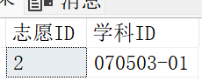

复试志愿触发器已完善

复试结果删除触发器：

CREATE TRIGGER trg_InsteadOf_Delete_复试结果

ON [education].[dbo].[复试结果]

INSTEAD OF DELETE

AS

BEGIN

-- 删除 获得 表中的记录

DELETE FROM [education].[dbo].[获得]

WHERE [复试结果ID] IN (SELECT [复试结果ID] FROM DELETED);

-- 删除 确定 表中的记录

DELETE FROM [education].[dbo].[确定]

WHERE [复试结果ID] IN (SELECT [复试结果ID] FROM DELETED);

-- 最后删除 复试结果 表中的记录

DELETE FROM [education].[dbo].[复试结果]

WHERE [复试结果ID] IN (SELECT [复试结果ID] FROM DELETED);

END;

测试：

-- 删除复试结果记录

DELETE FROM [education].[dbo].[复试结果]

WHERE [复试结果ID] = 1;

确定表中没有复试结果ID为1的数据

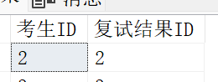

复试结果删除触发器已完善

测试：

-- 删除考生记录

DELETE FROM [education].[dbo].[考生]

WHERE [考生ID] = 11;

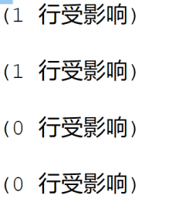

考生删除触发器已完善

测试：

-- 删除导师记录

DELETE FROM [education].[dbo].[导师]

WHERE [导师ID] =41;

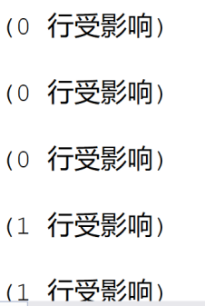

导师删除触发器已完善

**删除用户表触发器：**如果是导师就删除关联表的数据和导师表数据，如果是考生就删除关键表数据和考生表数据

CREATE TRIGGER trg_InsteadOf_Delete_用户

ON [education].[dbo].[用户]

INSTEAD OF DELETE

AS

BEGIN

DECLARE @角色名称 NVARCHAR(50);

DECLARE @用户ID INT;

DECLARE @角色ID INT;

-- 获取被删除用户的用户ID

SELECT @用户ID = [用户ID] FROM DELETED;

select @角色ID= [角色ID] FROM [education].[dbo].[用户] WHERE [用户ID] = @用户ID;

-- 获取该用户对应的角色名称

SELECT @角色名称 = [角色名称] FROM [education].[dbo].[角色] WHERE [角色ID] = @角色ID;

-- 如果角色是导师，先删除对应1表，再删除导师

IF @角色名称 = '导师'

BEGIN

-- 删除 对应1 表中的记录

DELETE FROM [education].[dbo].[对应1]

WHERE [导师ID] = @用户ID;

-- 删除 导师 表中的记录

DELETE FROM [education].[dbo].[导师]

WHERE [导师ID] = @用户ID;

DELETE FROM [education].[dbo].[作为]

WHERE [用户ID] = @用户ID;

-- 删除 用户 表中的记录

DELETE FROM [education].[dbo].[用户]

WHERE [用户ID] = @用户ID;

END

-- 如果角色是考生，先删除对应2表，再删除考生和用户

ELSE IF @角色名称 = '考生'

BEGIN

-- 删除 对应2 表中的记录

DELETE FROM [education].[dbo].[对应2]

WHERE [用户ID] IN (SELECT [用户ID] FROM DELETED)

OR [考生ID] IN (SELECT [考生ID] FROM DELETED);

DELETE FROM [education].[dbo].[作为]

WHERE [用户ID] = @用户ID;

-- 删除 考生 表中的记录

DELETE FROM [education].[dbo].[考生]

WHERE [用户ID] = @用户ID;

-- 删除 用户 表中的记录

DELETE FROM [education].[dbo].[用户]

WHERE [用户ID] = @用户ID;

END

-- 如果角色是其他，则只删除用户记录，不做其他删除操作

ELSE

BEGIN

DELETE FROM [education].[dbo].[作为]

WHERE [用户ID] = @用户ID;

DELETE FROM [education].[dbo].[用户]

WHERE [用户ID] = @用户ID;

END

END;

测试：

DELETE FROM [education].[dbo].[用户]

WHERE [用户ID] = 2;（角色为导师）

导师的信息及关联的信息均会被删除

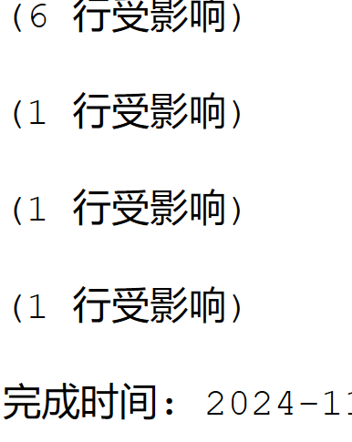

与导师有直接关联的表的数据也会被删除，例如复试志愿表不会在含有这个导师

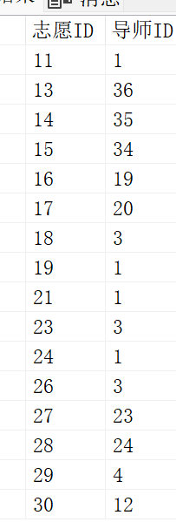

DELETE FROM [education].[dbo].[用户]

WHERE [用户ID] =3;（用户3是考生）

考生中的用户ID为3的已不存在 并且考生相关的所有信息均会被删除，详见考生删除触发器

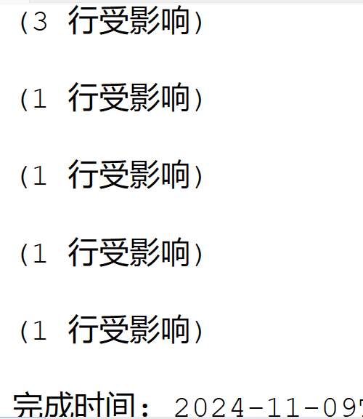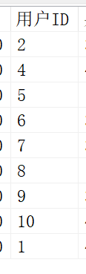

用户删除触发器已完善

测试学院：

delete from 学院

where 学院ID=10;

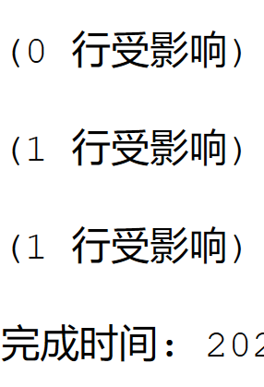

导师中以无学院ID为10的数据

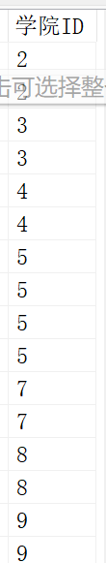

学科删除触发器已完善